Methodical instructions to laboratory work 5

STUDY OF MACRO PIPELINE COMPUTER SYSTEMS

The purpose of work. Analysis of functionality and efficiency of macro pipeline computer systems.

General information

The pipeline represents a processor, divided into P parts (layers, strings), executing step-by-step stages of each computational task (operation). During the execution of the j^{th} stage of some k^{th} task by the the j^{th} layer of a processor, the (j-1)^{th} layer can perform the (j-1)^{th} stage of the (k+1)^{th} task, the (j-2)^{th} layer can carry out the (j-2)^{th} stage of the (k+2)^{th} task and so on, i.e. the 1st layer of a processor can at the same time execute the 1st stage of the (i+j-1)^{th} task (where j=2,…, P). Thus, each task or operation is carried out in P stages after passing all P layers of the pipeline processor.
In CS with the pipeline processor several (P) operations of the data transformation can be performed at the same time that corresponds to the determination of the operating system. However these operations at any moment of time are obligatorily at the different stages of the execution and basically they can’t start simultaneously.
Pipeline systems with the shared control are called macro pipelines and oriented to the parallelism of independent branches (large or medium grain size concurrency). On the fig.1 the macro pipeline system with the shared control is shown. There are P control units (CU) in it – according to the number of layers, into which the pipeline processor is divided. The essentially important feature is the presence of Р separate nodes of the formation of the next instruction’s address; perhaps, that each CU has its own index and basic registers, registers of protection keys and other individual circuits. The part of circuits can be common for various CU (for example, the formation of the operands’ address, the decoder of the operations’ code), which are used by all CU by turns. These common circuits on the figure are included in the structure of processor’s layers.

А
LAYER 1
LAYER 2
LAYER Р
LAYER Р-1
T
H
E

R
I
N
G

S
W
I
T
C
H

CU 1
CU 2
CU Р-1
CU Р

Fig.1. General structure of macro pipeline system

Control devices are connected to layers of the pipeline processor by the ring switch. The switch is constructed in such a way that in the 1st step of the operation of CS the 1st CU, which starts the execution of its task (operation), is connected to the 1st layer of the processor; in the 2nd step the 1st CU is switched on the 2nd processor’s layer, and the 2nd CU is connected to the 1st layer and so on. In the r-m step the 1st CU is connected to the Р-th processor’s layer, where the execution of the 1st task (operation) is finished, the 2nd CU is connected to the (Р-1)-th layer,…, the P-th CU is connected to the 1st layer. After the finishing of the 1st task (operation) of the 1st CU in the (р+1)-th step the 1st device is connected again to the 1st stage of a processor, where starts the execution of the 2nd task (operation) and so on.
The system, constructed in the specified way, is similar by its opportunities to the Р-processor SMP system that oriented to the application with large or medium grain size concurrency.
The observed pipeline processor is multifunctional, i.e. it gives opportunity to execute simultaneously various operations. However at the same time the duration of the step of the operation of processor’s layers depends on the executed operations and is determined by the time of the execution of the most durable operation.

The task and initial data for the Laboratory Work №5

The initial data for the studying of macro pipeline systems:
- The parallel graph, the nodes of which correspond to the algorithms computational branches (fig.2).Weights of nodes give teacher.
- The number of pipelined processor’s layers (2 and 4).

The task for Laboratory Work:
1) Determine value of Т_{о} (in tact’s) for parallel graph;
2) Perform optimal assigning (scheduling) operations on processors of Macro pipeline system with various numbers of layers (2 and 4). Use program simulation PLASMA;
4) Determine execution time, speedup and application efficiency for various layers numbers of Macro pipeline system;
5) Choose optimal layers processors of Macro pipeline systems for using parallel graph and perform analysis results of systems working

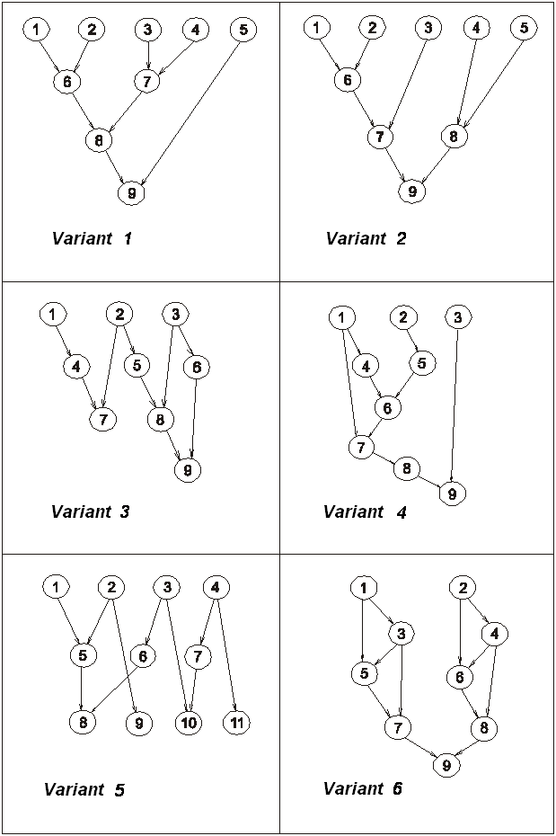
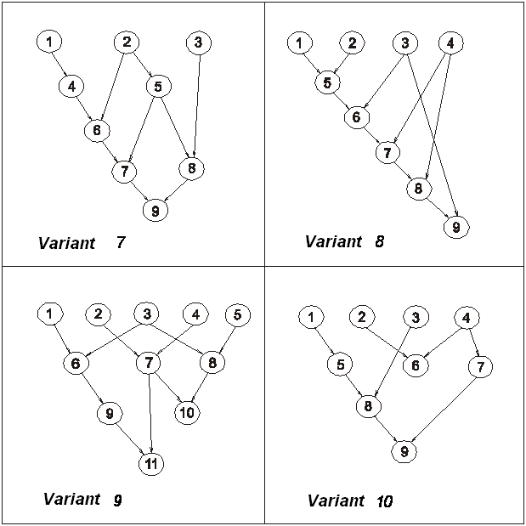

Fig.2 Parallel graph variants

